Dan Zhu

Assignment 4.2

Flowchart:

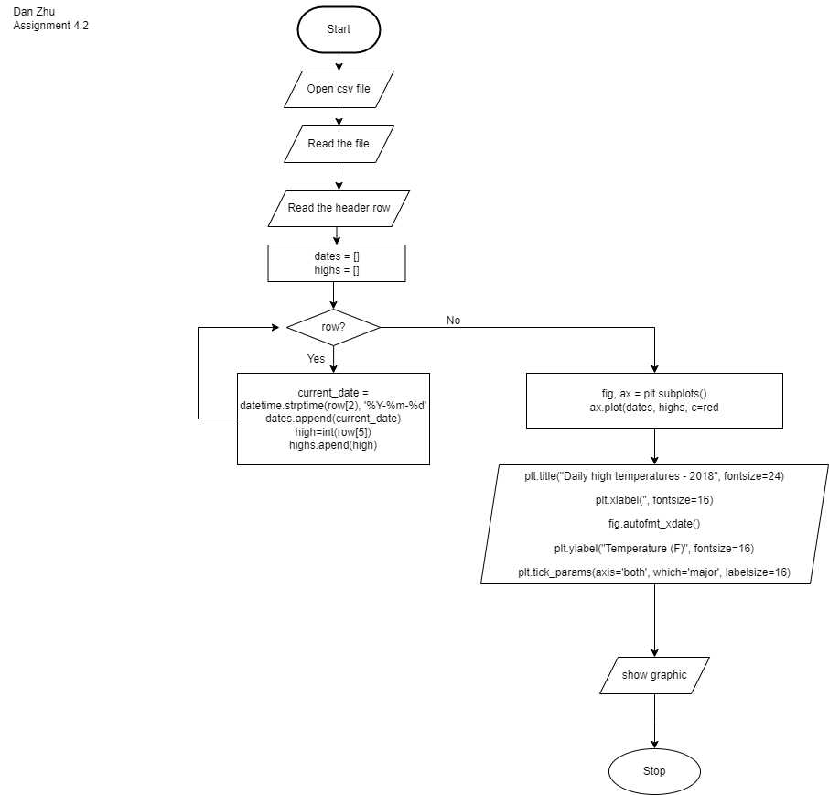

Flowchart Revised

